Tegrity – Install the Tegrity Recorder
1 | In Moodle, click on the Tegrity classes link. Open your Tegrity sessions.  Note: If you are already in Tegrity, close everything out and start over in Moodle. | 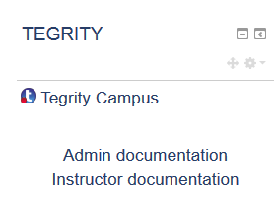
2 | Click Start a Recording
3 | Tegrity prompts you to download the TegRunner.exe file, which is the Tegrity Recorder. You need this to record anything in Tegrity.  Click Save File | 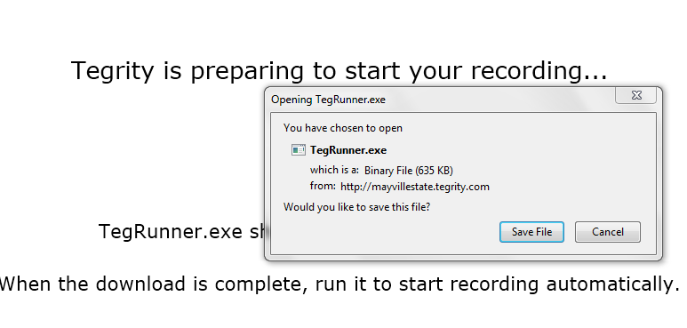
4 | Open your Downloads folder |  | Open Windows Explorer and click on the Downloads folder  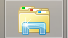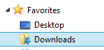
5 | Find the TegRunner file and double click it.
6 | A Tegrity dialog box will open and begin preparing your computer for the Tegrity Recorder installation.  Note: This dialog box stays on top of everything else while it runs.
7 | The Tegrity Recorder splash screen appears while it opens the recorder.
8 | The Tegrity Recorder opens and is ready to be used. |  | 