Quick Start Guide for Students

Table of Contents

Introduction 3
Terminate any previous MSU Zoom accounts 3
Activate Your Account 4
Download and Install the Zoom Client 6
Join a Zoom Meeting 7
Navigating a Zoom Meeting 8
The Meeting Window 8
Participant Panel 9
Awesome Zoom Tip! 9
Chat Panel 10
Troubleshooting 11

Introduction
Zoom is the leader in modern enterprise video communications, with an easy, reliable cloud platform for video and audio conferencing, collaboration, chat, and webinars across mobile devices, desktops, telephones, and room systems.
Terminate any previous MSU Zoom accounts
To terminate, go to Zoom.us and sign in. Then go to Account Profile and Click Terminate my account.
If you have a Zoom account from a previous trial using your Mayville State email address, you must terminate that account before you activate your new MSU account!
Go to Zoom.us and Sign In with previous trial account login info.
Go to Account Profile under the Account Management heading. | 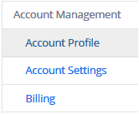
Click Terminate my account | 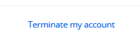
Say Yes to the Confirmation | 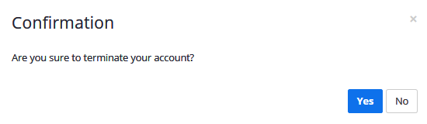

Activate Your Account
You will receive an email from Zoom explaining that a Zoom account has been created for you by someone at Mayville State. You are asked to Activate Your Zoom Account within 30 days.  Please click Activate Your Zoom Account to be added to the MSU Zoom account. Your username will be your MSU Email Address. | 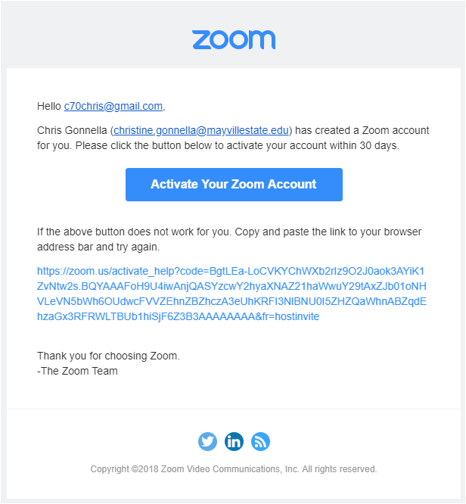
You will be taken to this screen  Choose Sign Up with a Password. | 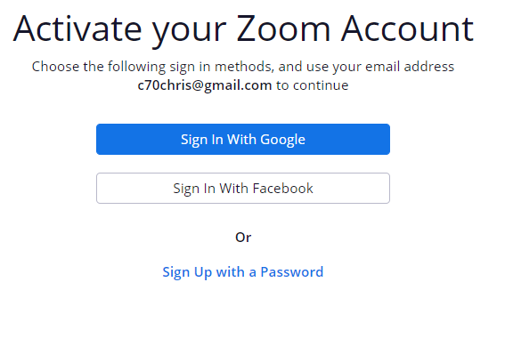
Complete the information below.  Click Continue  Reminder: If you have concerns about agreeing to the Privacy Policy and Terms of Service, do not continue this process and contact Chris Gonnella at Christine.gonnella@mayvillestate.edu | 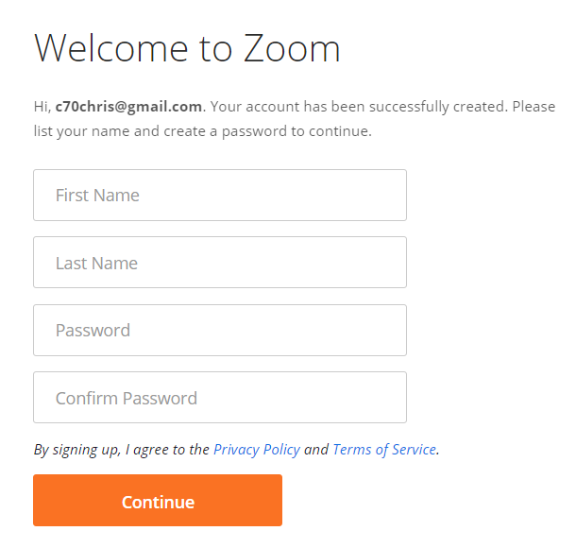
Choose Go to My Account.  This will take you to your Zoom account within the Zoom website.  Please DO NOT choose:  - Start Meeting Now  - Start or schedule Zoom meetings directly from your browser.  These two options will utilize the web-based version of Zoom which does not have the features you need.  Download the Zoom Client for the best experience. | 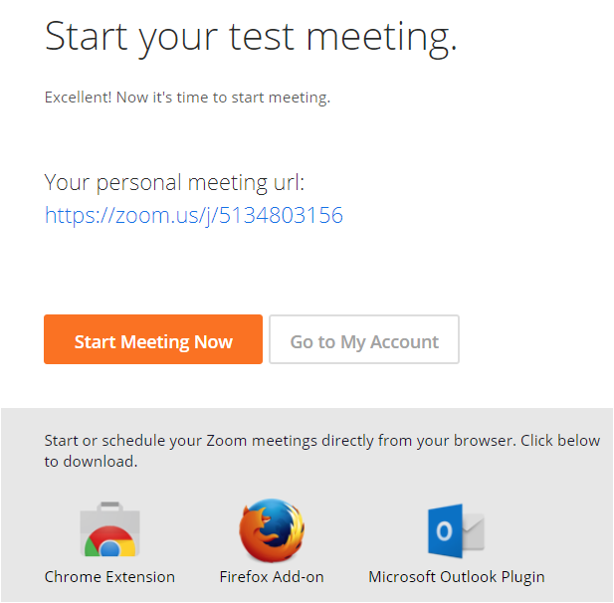

Download and Install
the Zoom Client
In your browser, go to https://zoom.us/download.  Go to Zoom Client for Meetings  Click the Download button and follow the prompts to install. | 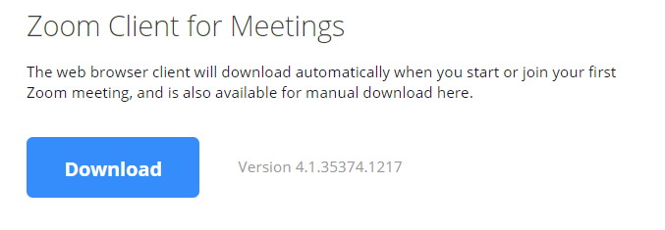
To open the Zoom client, tap the Windows key on the keyboard and type “z”.

Start Zoom Desktop app will pop up. Click it to open the Zoom app.
The Zoom client allows you to control Zoom from this Home page.  See the Student Guide to Getting Started with Zoom for more detailed information on the Zoom client. | 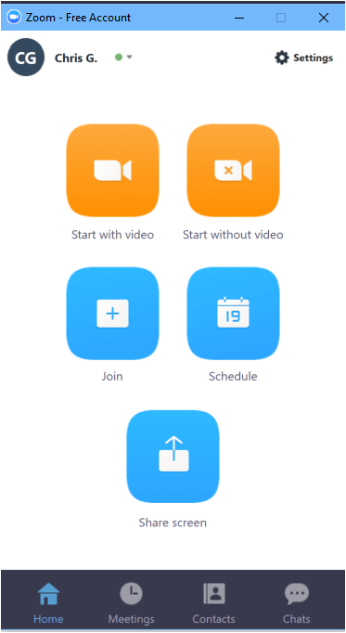

Join a Zoom Meeting
To open the Zoom client, tap the Windows key on the keyboard and type “z”.

Start Zoom Desktop app will pop up. Click it to open the Zoom app.
Click Join to enter a pre-scheduled meeting.

You will need the meeting ID if it has not already been used with your Zoom client.

Meeting IDs are six digits long.
A window opens where you can type in the meeting ID for your class meeting. This information should have been sent separately. | 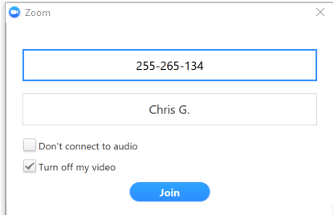
The next time you click on Join in the client, this meeting will be in your history until you decide to clear it. | 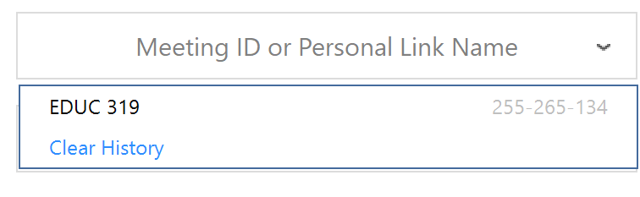

Navigating a Zoom Meeting
The Meeting Window
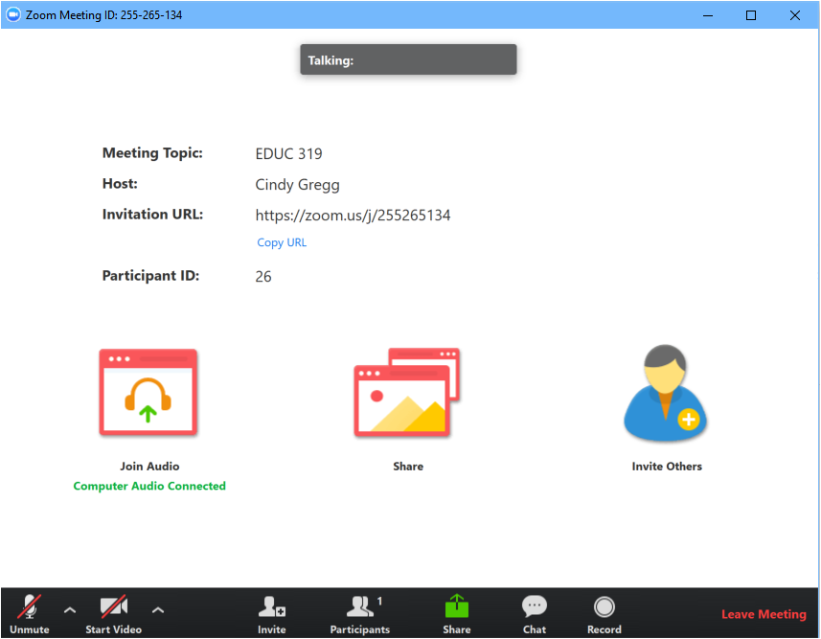
The first thing you should do when joining a Zoom meeting is to click the Exit Full Screen mode button.  When you are in Full Screen, you cannot see your taskbar and it is easy to get confused about where to find everything. | 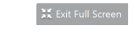
Next, click the Restore button to enlarge the Zoom meeting window.
With the Zoom meeting screen open in the Restore position (as described above), Open the Participants and Chat panels. | 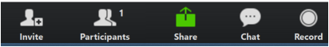
Participant Panel  Shows whether you are muted and if your camera is on or off.  Shows all other participants and their mic and camera status  Allows you to raise your hand or use other icons to indicate your status. This may be used by your instructor get feedback from you on the technology, and how you’re doing with the content of the class.  Hosts and co-hosts can lower your hand and clear other responses. | 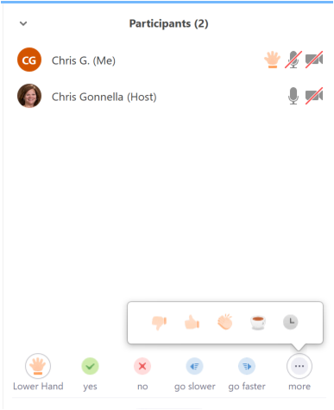
Most meeting hosts will set the meeting so that attendee mics are muted and cameras are off. This allows the attendee to control when they are heard and seen. | 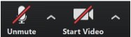
To mute/unmute your mic, use Alt + A | 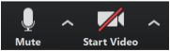
To start/stop your camera, use Alt + V | 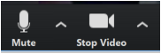
Awesome Zoom Tip!  To temporarily unmute yourself,  press and hold the spacebar.  Release to re-mute. | 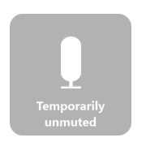
Hosts can mute and unmute one or all participants. Either way, you will be notified as shown here:
Hosts can also request that you start your video…. but you must give permission. | 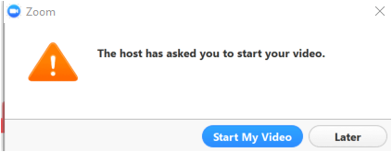
Chat Panel  Chat allows you to have a text-based conversation with anyone else in the meeting.  You can close, minimize or pop the chat window away from the meeting if you prefer to separate the two.  Some meetings allow attendees to chat with others privately (this one does not).  This meeting is set up to allow you to upload and download files via the chat window. | 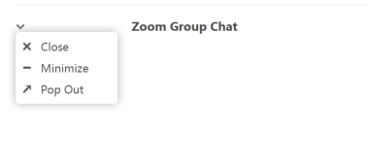  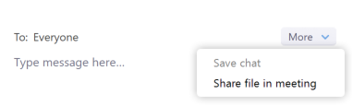

Troubleshooting
To troubleshoot audio, click the up arrow next to the mic icon.  - Check the correct mic is being used.  - Click on Audio Settings… to explore other options. | 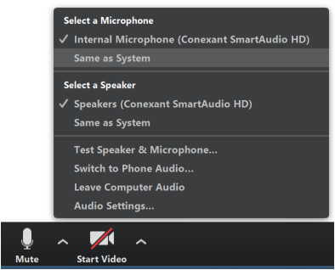
To troubleshoot video, click the up arrow next to the camera icon.  - Check the correct camera is being used.  - Click on Video Settings… to explore other options. | 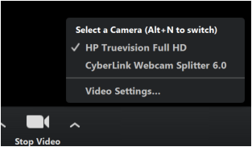
Remote Control  Zoom has a remote-control feature that allows you to get or give access to the mouse and keyboard of someone sharing their screen with you.  In an active Zoom meeting with the person who is going to examine your computer, share your screen and choose a window to share.  Click Remote Control and choose Give Mouse/Keyboard Control to: Chris Gonnella | 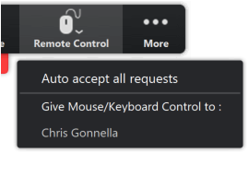
To end the remote-control, click Abort Control. | 