Executive Overview
Blackboard Implementation Consultation Mayville State University

Ken Martin, Ed.M.
Marty Holland
April 11-13, 2017

CONFIDENTIALITY NOTICE
This document and its contents are confidential and proprietary to Blackboard, Incorporated and are intended only for the individual or entity specified herein or otherwise identified by Blackboard, Incorporated.
If you are not the intended recipient of this document, you are hereby notified that inadvertent disclosure of this document to you does not constitute waiver by Blackboard, Incorporated of the confidentiality of this document and its contents. If you have received this document in error, please immediately call Blackboard, Incorporated, toll-free, at 800- 424-9299, to arrange for return of the document at the cost of Blackboard.
If you are not the intended recipient of this document, please note that this document and any of its contents may not be reproduced or distributed without the prior express written permission of Blackboard’s legal counsel.
Unauthorized use, reproduction, or distribution of this document or any of its contents may result in legal and financial penalties.
Purpose 4
Introduction 4
Key Takeaways 5
Mayville State University Mission Statement and Strategic Outcomes 5
Business Drivers 5
Scenarios 6
Synchronous Technical Support for Students 6
Interactive Learning 7
Business Comprehensive 7
Gradebook 7
Flipped Classroom 7
Third Party Online Learning 8
Communication Plan 8
Course Development Life Cycle (currently in Moodle) 8
Training Plan and Transition Timeline 9
Project Risks and Success 11
Champion Mentality 12
Partnering Approach with Blackboard 12
Recommendations 12
Opportunities 13
Conclusion 14
Appendix I Agenda 15
Appendix II Course Life Cycle 16
Appendix III Timeline 17
Appendix IV Resources 18

Purpose

The purpose of the Academic Technology Planning (ATP) Service is to engage multiple levels of the institution to identify project objectives and align those objectives with the strategic goals of the institution. Specifically, the Academic Technology Planning Service strives to:

- Include the voice of academic leadership, faculty, administrators
- Identify key stakeholders of the Blackboard Solution
- Brainstorm with a cross representative audience to determine scenarios
- Collect and prioritize desired outcomes from the Core team and key stakeholders
- Align scenarios to outcomes
- Create action plans to move the outcomes forward
- Discover gaps and document potential issues

Introduction

This executive overview is the result of the Blackboard Academic Technology Planning Consultation Service for Mayville State University, which occurred onsite at MaSU on April 11-13, 2017. In planning for the sessions, MaSU noted specific objectives as a starting point, and the agenda was crafted to ensure those were covered as a part of the sessions. This report focuses on planning for the transition to Learn, deployment of Collaborate Ultra and possible implementation of the Content System. A timeline for the transition to SaaS was developed. The transition to SaaS will have a separate, detailed work stream specific to that area once MaSU is engaged with Blackboard’s Hosting team.

The intended purposes of this document are as follows:

- Document discussions and conclusions reached during the implementation planning consultation sessions
- Establish goals for the Blackboard Solution Implementation that align with broader institutional goals
- Develop an implementation timeline with identified resources to ensure successful expansion of the Blackboard Solution
- Make recommendations for next steps

While we recognize that shifting contexts may necessitate a rethinking of the information and recommendations contained within, this report should be utilized as a record of a specific perspective based on known variables during the time of the consult.

Key Takeaways

- Academic Technology Planning Service discussions occurred onsite April 11-13, 2017
- Several scenarios/use cases were developed by the core team and meeting participants and were used to develop a customized training plan
- Business Drivers were identified that the Blackboard solution could assist the institution in accomplishing
- A detailed high level timeline was developed to prepare MaSU for the transition to Learn in SaaS
- Planning data can be found here: http://bit.ly/masu-planning
- MaSU currently deploys the Moodle LMS and the Blackboard Collaborate web conferencing solution and is looking to achieve the following:
- Transition to the North Dakota shared SaaS deployment of Learn with a desired “go live” start date of May 15, 2018

Mayville State University Mission Statement and Strategic Outcomes
The core project team reflected on the MaSU mission and strategic outcomes. Through an engaged discussion, the team identified key business drivers to which the Blackboard solution could help MaSU make progress. The mission statement and drivers are documented below.

Mission Statement: Mayville State University is dedicated to excellence in teaching, service, and scholarship in dynamic, inclusive and supportive learning environments that are individually focused. We offer quality undergraduate and master's programs enriched with practical experiences to prepare all learners for a global economy.

Business Drivers

Business Drivers

Scenarios

Implementation Outcomes

After reviewing MaSU’s mission the core team and meeting participants discussed the impetus for the Blackboard project. The following drivers were submitted as criteria the Blackboard Solution will ideally fulfill to most benefit the institution.

- Streamline student grading and feedback for faculty so faculty can get back to students in a timely manner (Retention)
- Have all the resources needed within the Bb environment (reporting, assessment, surveying, etc.) for faculty and students.
- Improve use of educational tools to grow teaching practices and data collection
- Help our students learn to set and achieve reasonable learning goals

Scenarios

Scenarios capture the intended uses of the Blackboard Solution by faculty, staff, and students and serve as areas of focus to help grow the adoption of Blackboard. These scenarios were developed to assess the potential impact each will have, mitigate risks and understand the training, communication and support necessary for success. The faculty submitted scenarios ranging from specific tools in Blackboard to establishing new workflows based on Blackboard affordances. At present Moodle is primarily used to support online classes although a sub-set of faculty use it to augment their face-to-face classes as well.

End User

Problem / Issue / Need

Training Req.

Support Req

Student Impact

Institutional Impact

Synchronous Technical Support for Students
This scenario addresses the need to provide technical support for online students. MaSU would like to provide a live chat function through which online students can access technical support. The institution will consider extending services to new and/or prospective students as well. This scenario will address the need to provide quick access to staff during high traffic or other times so that troubleshooting occurs more rapidly than at present. The institutional impact is estimated to ultimately affect retention and the overall student experience.

Interactive Learning
Online courses tend to be primarily an asynchronous experience for students. This scenario addresses the need to increase interactive learning in courses using synchronous video communication and, secondarily, increase non-synchronous learning using recordings of the communication. The student impact will be increased student engagement which is anticipated to result in increased retention.

Business Comprehensive
Business Comprehensive is the capstone course for MaSU’s Bachelor of Applied Science (BAS) degree. The BAS degree program accepts all the credits from a completed two-year degree, then allows students to earn a four-year degree after completing as few as 60 additional credits (120 total). Consequently, most of MaSU BAS degree seekers are online students. Course work culminates in a student presentation via Collaborate Original. Students, at a minimum, must include PPT content in their presentation. There have been some technological issues in the past that have interfered with the student presentations, issues that have increased student anxiety during the presentation. Consideration should be given to migrate this scenario to Collaborate Ultra which will continue to receive enhancements like persistent whiteboard content. The student impact will be affected by permanently moving to Collaborate Ultra and introducing students to this medium frequently over the course of the term through office hours, class meetings, and practice sessions. As a capstone course, the institutional impact will likely be manifested through a positive student experience and confidence gained in navigating technological glitches that arise, which should reflect positively on the overall BAS degree experience.

Gradebook
Several faculty reflected on the importance of having efficient work flows and flexible grading schemas in the Bb Grade Center. There is a need for faculty to categorize gradable items and for in-term adjustments to assignments and assessments that will not disrupt how the grade center is configured. There is also a need for students to easily view their grades across categories. The impact on students will be a better student understanding of how the assignment contributes to the grade and if any assignments are missing. The institutional impact will rely on effective communication to students on how grades are calculated and constructive feedback on assignments.

Flipped Classroom
This scenario presents the use of Blackboard as a medium to provide lecture videos and note outlines for students to consume before attending class on campus. Students will take a quiz on the day’s content then socially engage in learning activities while in class. Critical for ensuring a positive student impact is making the videos easy to access. The overall institutional impact will be to model effective pedagogy, support the integration of technology into the on premise classroom and promote the use of technology on campus.

Third Party Online Learning
The crux of this scenario is a tighter integration between 3rd party vendor supplied learning content and the Bb Learn LMS particularly in online biology. At present faculty are faced with inefficient workflows when they must manually transfer grades from the 3rd party content area back to the Moodle grade book. Faculty need grades to automatically populate the Bb Grade Center. MaSU is encouraged to engage CTS and the governance committees to implement the transmission of grades to the Bb Grade Center. A deeper integration and grade transfer between vendor content and Bb will positively impact the online learning experience for students and faculty. The institutional impact is improved faculty workflows and enhanced online course management.

Communication Plan
The core project team recognizes the importance of bringing transparency to this project. Building awareness among the MaSU community is an essential component of continued effective change management. Several strategies were discussed during the consultation engagement including newsletters, Web content, leadership engagement, and working with early adopter faculty as a conduit to the faculty and administration at-large. The closeness of the MaSU community will assist in communication.

Course Development Life Cycle (currently in Moodle)
The life cycle of a MaSU course was diagrammed to develop an understanding of this process and how it will be accommodated and/or impacted with a transition to Learn in SaaS. The course life cycle was used, in part, to generate a transition to SaaS timeline.

Key Findings in Course Lifecycle
- 85 day off set for course creation
- Faculty access to course shells is by request
- Course shell available to faculty when moved from SPLASH category to Term category
- Student access course shells 1st day of term or session
- Credit based courses are created through a feed from PeopleSoft to Moodle however some manual manipulation of course information occurs before the final load into Moodle
- Approximately 110 faculty teach approximately 400 courses during the fall with a similar number in the spring. Summer courses number around 140.
- Expectation is that at a minimum each course will have a syllabus and course information included in the course template
- Non-credit courses are supported through a manual course creation process
- Courses are made unavailable to students 2 weeks post-term unless there is an incomplete.

Areas for Consideration:
- Engage faculty on strategy on how to manage ‘incompletes’ when transition to Learn is made in May 2018. The team raised the possibility of setting policy that no ‘incompletes’ would be given for Spring 2018 so that the Moodle course would not need to be maintained in the current environment until the ‘incomplete’ had been remedied.

Training Plan and Transition Timeline
Critical to the ongoing success of the Blackboard project is preparing MaSU faculty to teach in Bb. To ensure faculty have a fundamental understanding for how Bb Learn functions, the core team developed a short-term training plan for faculty. The plan includes remotely delivered, recorded workshops for faculty and administrators. The core team determined that training will initially be focused on administrator skills and knowledge to prepare the core team to support faculty. This training will also prepare the core team to convert, test and QA courses as they’re migrated into Learn. After a bulk of the courses have been converted and migrated, the focus will turn to faculty with faculty training starting in earnest during the fall 2017 term. Additional formal training for faculty teaching during the summer 2018 term will be delivered before spring break in March 2018. This will be followed by more training for summer and fall 2018 faculty in April and early May 2018.

Bb End User Training Modules:

Fall 2017:
- #1 Designing Course Structures;
- #4 Designing Engaging Discussions;
- #5 Creating and Managing Assignments;
- #8 Mastering the Grade Center; and possibly,
- #6 Creating and Managing Tests
- #3 Monitoring and Retaining Students

MaSU will continue to engage with Bb to ensure all necessary services are scheduled for the MaSU community.

MaSU staff will use the Blackboard Course Conversion tool to migrate courses from Moodle to Blackboard.

If a faculty member’s course has not been migrated when training starts, MaSU may create practice shells on the STAGING server. MaSU has been advised these are temporary shells and will not be carried over to the PRODUCTION server. It is suggested MaSU communicate with NDUS CTS for ongoing practice shell needs.

MaSU core team will meet with Bb technical resources starting in late summer 2017 to discuss SIS integration and transition to SaaS. To prepare for these discussions, the core team outlined a high-level transition timeline. The timeline is presented below.

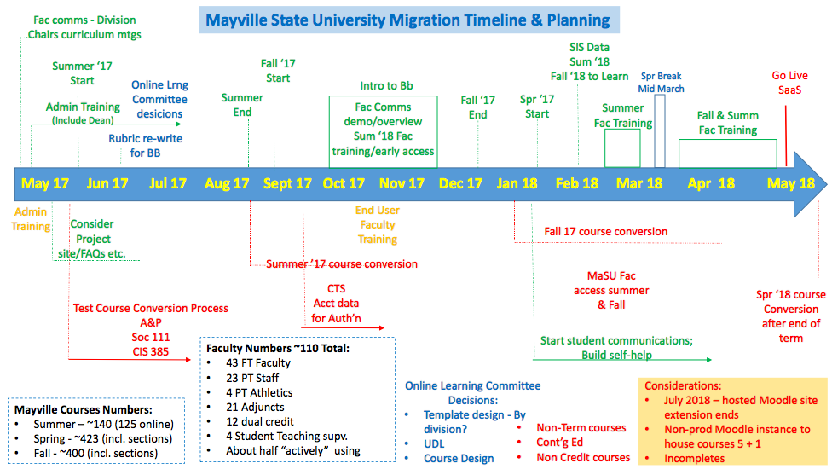

Key Findings in Transition Timeline
- MaSU desired target go live date in Learn in SaaS is May 2018
- Blackboard end user training will be offered to MaSU faculty during fall 2017 and spring 2018
- MaSU admins will receive LMS Admin training starting May 2017
- Course conversion will occur in phases: a few test courses will be migrated by MaSU in May 2017 with subsequent terms to be converted at the conclusion of each term
- The Online Learning Committee will meet summer 2017 to evaluate and modify (if necessary): course rubrics, course templates, and policies around accessibility and universal design as they relate to the Bb course environment.
- The MaSU core team will coordinate with CTS on end user access to Learn environments such that authentication processes are in place to support end user access

Project Risks and Success
The core team identified the following risks and mitigations that could impact the transition to Learn in SaaS. The team is encouraged to continue discussions on the mitigation of these risks with MaSU stakeholders, NDUS and ND Governance.

Risks
- Content not moving correctly
- Amount of work if courses need to be rebuilt
- System downtime
- Faculty anxiety
- Limited resources/time
- Org or staff changes – May 2018 is a year away, small campus staff
- Negative perceptions around the move from Moodle to Bb
- Integrations not working (e.g., Nursing – Task Stream, etc.)
- Storage size – uploaded video using excessive storage
- Ability to cross train within MaSU to build redundancy

Mitigations
- Plan, plan, plan - continually
- Promote the positives
- Marketing and open communication across all levels of MaSU
- Set realistic expectations for faculty
- Adjust faculty schedules, if necessary, to account for course development and /or training opportunities
- Consider faculty incentives
- Include multiple people in the training to promote back up and cross training

Key Areas for Consideration
- Continue discussions to mitigate risks and identify new ones as project progresses
- Execute mitigations
- Develop and document a QA plan for testing converted courses in Learn in SaaS. Contact CTS and/or other ND schools for sample test plans

In addition to identifying risks and mitigations, the team identified the following criteria for success looking out 1-2 years from April 2017.
- “Happy faculty”
- Seamless transition for students (Note, some students come from Lake Region, Williston and NDSCS)
- Innovation – look ahead to try new things. Open minded pockets to become advocates.
- Robust new faculty onboarding process - Onboarding & Training for new faculty to ensure support & adequate training for adjuncts
- Strong social presence in online courses
- Greater adoption
- More consistent use
- Provide student services via Bb
- Leverage Bb to support full student life cycle
- Stronger sense of communication/connection - Fac/Student/Staff Communication - Greater connectivity/engagement/collaboration (students to engage with each other, with instructors, etc.)
- Increase in online student community/opportunities
- Maintain level of personal support and interaction

Champion Mentality
In implementations where the use of collaborative technologies is new and uncharted, a key hallmark for success is what we call the ‘champion’ mentality. This is evident in those users who are driven by the goals of the implementation to overcome challenges with changes in technologies, policies and procedures along the way. These are the same users who will attract later adopters with the stories of success and create the foundational usage that is the stepping-stone to more wide scale adoption. The learning curve they are willing to ascend matures the implementation to a stage where this is possible.

Partnering Approach with Blackboard
In our experience a successful implementation is characterized by a partnership approach to working together. These implementations are where organizations are actively seeking our input, polling us for industry experience and relying on us for best practice advice. All our services are designed to be utilized in this way, in contrast to “calling on” them as a last resort.

This also means utilizing our technical support services in a consistent and persistent manner allowing us to ensure your users have 24x7 access to accurate and comprehensive support information. Successful implementations are characterized as having put in place early on policies and expectations with users on how they should or should not utilize this service and how matters should be escalated where necessary.

Recommendations

- Actively participate in the ND Governance Committees to drive communication and decision making
- Use of the Blackboard Content Management System requires coordination with CTS and ND Governance. Coordinate implementation with CTS and other ND institutions accordingly
- Develop a course archiving strategy that aligns with MaSU business needs (e.g. grade disputes). Engage Blackboard Service Delivery Manager on process for archiving courses. Coordinate as needed with CTS and other ND institutions.
- Validate the key business drivers with MaSU Senior Leadership to ensure the correct alignment of the implementation with the university’s strategy and priorities.
- Coordinate with Bb and CTS if using sandbox shells on the STAGING server
- Evaluate Blackboard Learn Goals and Alignment capability to see if it meets MaSU needs. Engage NDUS system administrators on set up and roll up extraction of goal sets.
- Monitor the latest features and functionality in Blackboard Learn with the Ultra experience to determine the most opportune timing for MaSU’s transition to an Ultra course experience
- Continue to work with Senior Project Manager, Marty Holland, to schedule remaining services

Opportunities

Blackboard Learn has a wide array of functionality to support the business processes of the academic enterprise. The core team must focus on a successful migration from Moodle to Learn but once this phase is complete, there will be opportunity to grow the adoption of Learn to support other areas of the institution. The following suggestions are for consideration by the MaSU core team.

- Blackboard Organizations can support a wide variety of non-course groups within MaSU. Consider using Organizations to support student clubs, student athletics, student government, departments, committees, advising and tutoring.
- The Content Management System in Blackboard Learn can bring operational efficiencies to how faculty manage content in courses. Similar efficiencies can be gained at the institutional level through this system. The core team discussed possible uses of the Content system, perhaps beginning with institutional policies in summer 2018.
- Blackboard’s mobile app, Bb Student, provides a range of capabilities including the viewing of content, submission of student work and the ability to join Collaborate Ultra web conferencing sessions. Bb Student is also an “ultrafied” app and can be an incremental step to acclimate students to the new design and workflows in Learn Ultra. Bb Student will work with Learn Original courses. MaSU is encouraged to consider a mobile initiative to promote and drive adoption of the Learn LMS at MaSU.

Conclusion

MaSU has made significant strides in evolving its educational technology ecosystem by planning to implement the Blackboard components. As with any project of this magnitude, risks and challenges that may impact on going implementation efforts emerge. The core team should maintain ongoing project meetings to address any challenges that arise. Overall, the College is positioned for success with the next implementation of Blackboard. We look forward to assisting MaSU as it continues to evolve its educational technology ecosystem with the Blackboard Solution.

Appendix I Agenda

TIME | Day 1 | Day 2 | Day 3
8:30pm | 1.0 ARRIVAL & LOGISTICS | 1.0 ARRIVAL & LOGISTICS | 1.0 ARRIVAL & LOGISTICS
9am | - Welcome and Introductions | 2.4 Course Design  Lifecycle | 3.4 Measuring Success
9:30am | 2.1 Bb Solution Overview  2.2 Learner Scenarios  and  Use Cases  2.3 Drivers and Outcomes
10:00am |  | 2.5 Learner  Lifecycle Stakeholders | 3.5 Action Plans  for Transition
10:30am
11:00am |  | 2.6 Learner Support  Services Ecosystem
12pm | LUNCH | LUNCH | 3.6 Meet with  Project Manager
1pm | 2.1 Bb Solution Overview  2.2 Learner Scenarios  and  Use Cases  2.3 Drivers and Outcomes | 3.1 Refine and Align:  Outcomes and Scenarios
2pm |  | 3.2 High-Level Transition  Plan to SaaS
3pm

3:45pm | - Wrap Up | - Wrap Up | 1.3 Closing Meeting

Appendix II Course Life Cycle

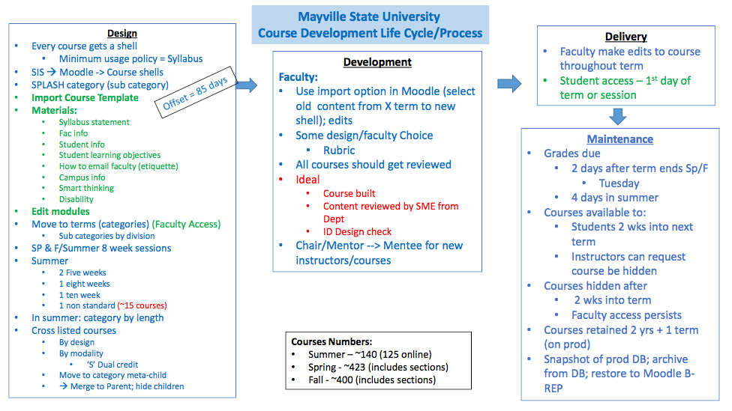

Appendix III Timeline
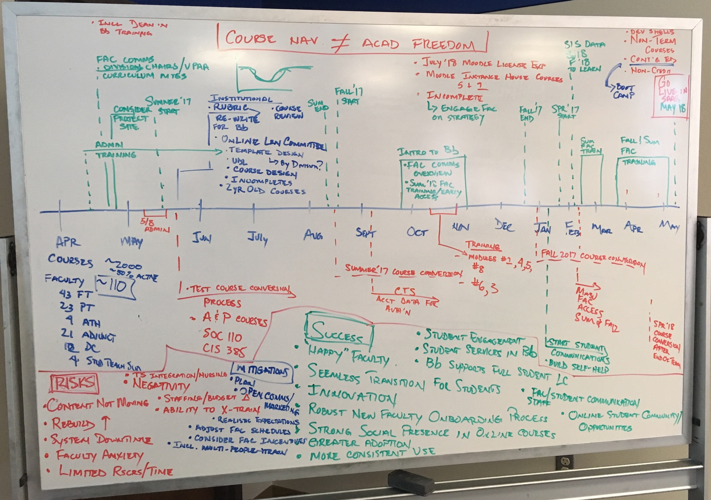
Appendix IV Resources
Resource | Location
Educator Preview | http://preview.blackboard.com
Blackboard Community | https://community.blackboard.com/welcome
Blackboard Status | http://status.blackboard.com/
Blackboard Help | https://en-us.help.blackboard.com/
Collaborate End User Tech Support | https://blackboard.secure.force.com/btbb_publichome?dfprod=Collaborate
Client Support Services Guide | https://blackboard.secure.force.com/btbb_articleview?id=kA570000000PB0o
SaaS: Operations | https://en-us.help.blackboard.com/Learn/Administrator/SaaS/Operations
Browser Support | https://en-us.help.blackboard.com/Special:Search?path=Learn%2F9.1_2014_04%2FAdministrator%2F020_Browser_Support&q=Browser%20Support&limit=11&page=1&tags=
Adoption Tools and Best Practices | https://en-us.help.blackboard.com/Learn/9.1_2014_04/Administrator/010_Release_Notes/090_Release_Notes_9.1_2014_04/Adoption_Tools_and_Best_Practices
Technology Adoption | http://bbbb.blackboard.com/technology_adoption_series
Training Program Development | http://www.blackboard.com/resources/training/tpdtakeaway.pdf
Bb Student Communication and Adoption Toolkit | https://en-us.help.blackboard.com/Bb_Student/Administrator/zBb_Student_Communication_and_Adoption_Toolkit
Content Collection | https://en-us.help.blackboard.com/Learn/9.1_2014_04/Administrator/060_Application_Management_and_Support/Tools_Management/210_Content_Collection/010_Setting_Up_Content_Collection/000_Setting_Up_Content_Collection
Bb Student | https://en-us.help.blackboard.com/Bb_Student/Administrator/Release_Notes_for_Bb_Student
Course Templates | http://library.blackboard.com/ref/df5b20ed-ce8d-4428-a595-a0091b23dda3/Content/_admin_app_course/admin_app_course_template.htm
Date Management | https://en-us.help.blackboard.com/Learn/9.1_Older_Versions/9.1_2014_and_2015/Instructor/090_Course_Content/020_Reuse_Content/070_Date_Management
Exemplary Course Information | http://www.blackboard.com/consulting-training/training-technical-services/exemplary-course-program.aspx
SaaS Service Levels | http://library.blackboard.com/docs/support/Blackboard_Learn_SaaS_Specifications_and_Service_Levels.pdf
Collaborate Storage Allocation | http://library.blackboard.com/docs/support/Blackboard_Collaborate_SaaS_Storage_Specifications.pdf

See Appendix I
See Appendix III for course life cycle diagram
See Appendix III for timeline whiteboard

