How to Edit Your Moodle Profile

Login to Moodle. | Http://www.mayvillestate.edu
Click on My Profile located above your name. | 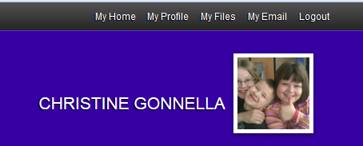
Under the Administration block, click on Edit Profile | 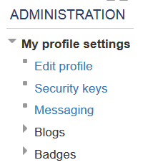
Change any of the fields shown here. | 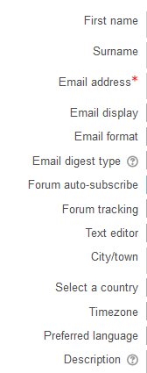
Change other information under these buttons | 