How to enable student recordings

Navigate to your course in Moodle
Click the Tegrity Campus block in your Moodle Course.  (If you do not know how to get the Tegrity block in your course, see the tutorial, “How to add a Tegrity block.” | 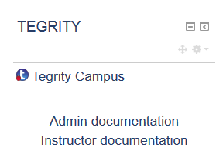
Under the Course Tasks drop-down, select Course Settings | 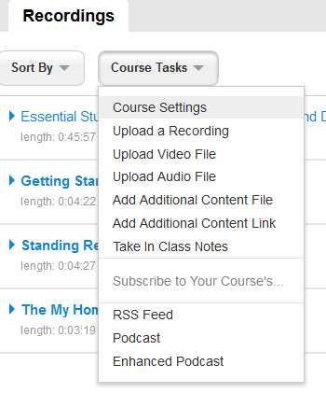
Under the Recording heading, check Allow students to record | 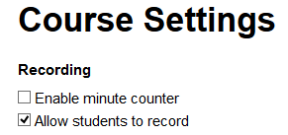
The instructor then needs to decide if student recordings are public (meaning available to the entire class) or only viewable by the student and the instructor. If the instructor doesn’t want other students to see classmate recordings, they must uncheck the box under the Publishing heading that says Automatically publish student recordings. | 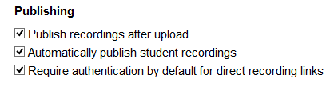
Click OK | 