Add a Discussion Forum
Navigate to your course in Moodle
Turn editing on.
Click Add an activity or resource
Scroll down into the Activities section to locate Forum.

Double click Forum.
Enter the Forum name and a Description of the assignment. | 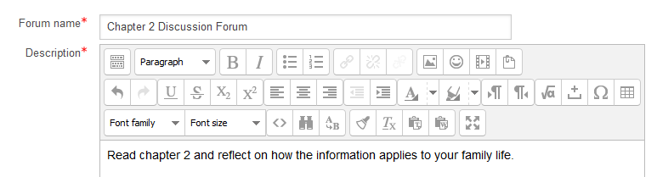
Choose the Forum type. | 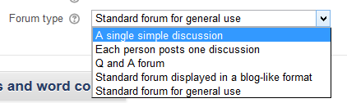
To grade the forum, use the Ratings section. | 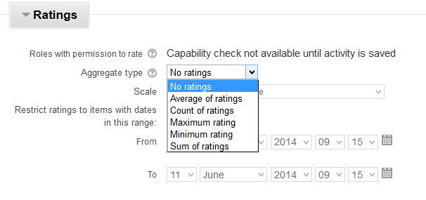
Save.

