Post to the Announcements forum
- Login to Moodle and go to your course.
- Click on the Announcements forum:
By default, all courses have an Announcements forum. This forum allows the instructor to send class-wide emails to the address that is in each participant’s Moodle profile. Each individual is able to change the email address in his or her profile so keep in mind that your message may not be sent to the MSU email account.
Participants in your course cannot respond to the Announcement forum. It is a one-way communication tool.
*If you do not have an Announcements forum, contact the Moodle Help Desk to insert it into your course.
3. Click the Add a new topic button

4. Enter your Subject
5. Enter your Message
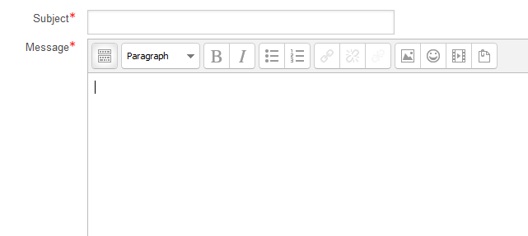
6. Click the Post to Forum button
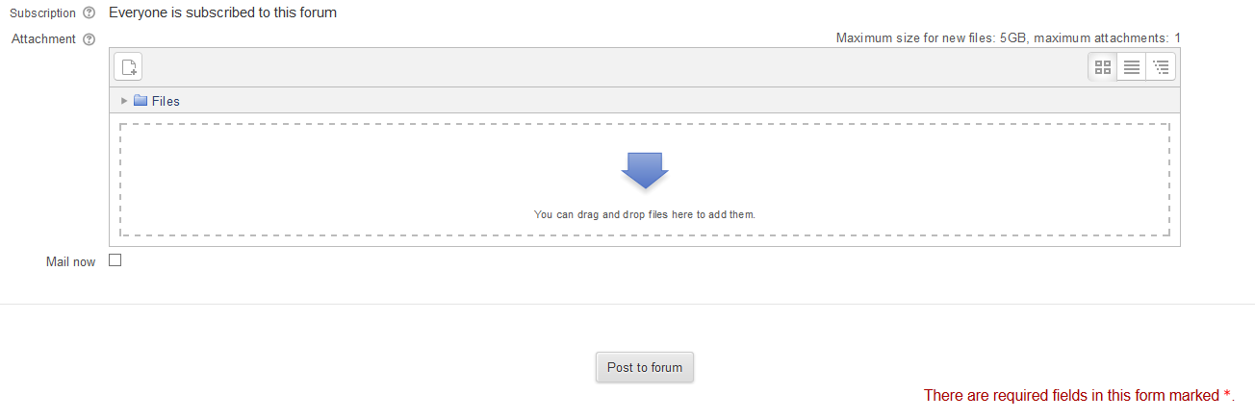
7. You will receive the message below. Notice the notification that you have 30 minutes to edit your message.
8. Click Continue
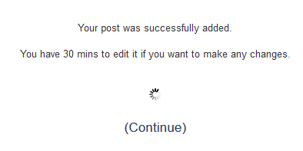

9. Your message will be posted to the forum and sent to all participants in the course. The date and time you last posted is also displayed.
10. To edit your post, click the name of the post (in this example, the name of the post is “Welcome”).
11. Then click Edit.
12. Make your edits and click Save changes.
